- Task 1 Identify data quality issues in the dataset.
- The data set contains 117 missing values
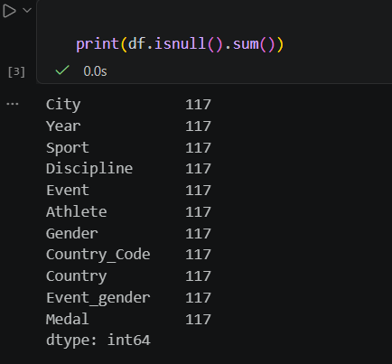
- And 117 duplicate rows
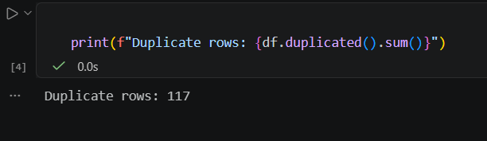
- Incorrect Data Type. "Year" is stored as "float64"
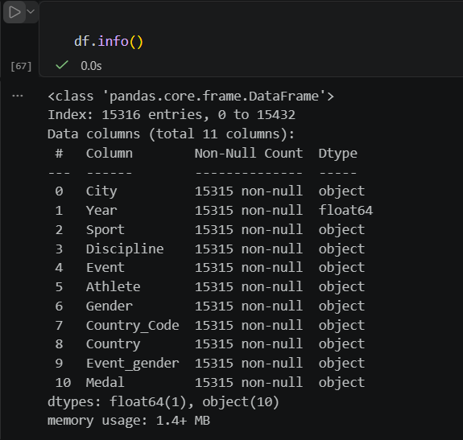

- One athlete's `Gender` field says `Men` while the `Event_gender` says `W` (Women's event)
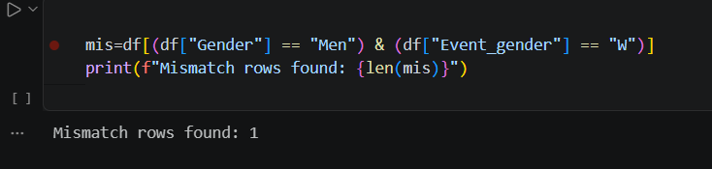
- Five countries carry a `*` character (e.g. `Puerto Rico*`, `Hong Kong*`). This asterisk is not part of the country name.
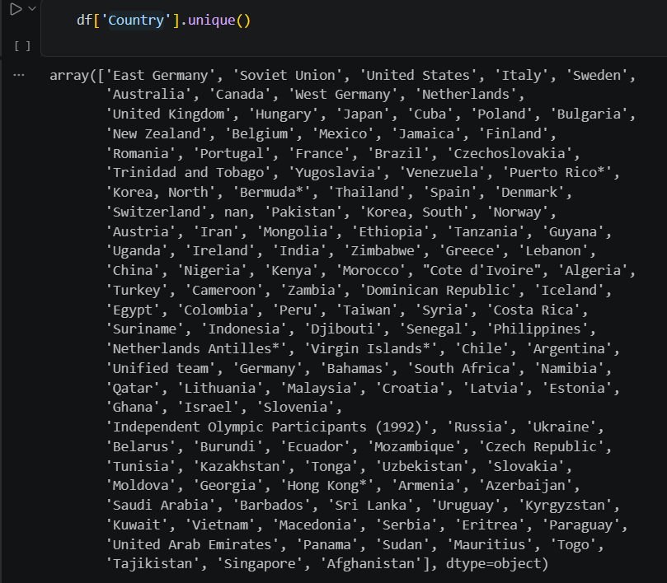
- The dataset contains competitors who participate in the Olympic Games under the ‘Olympic flag’ instead of representing a specific nation.
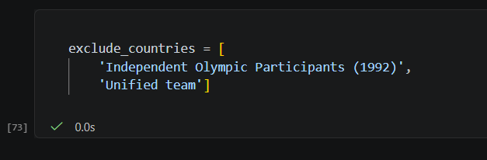

- Task 2 Apply one missing value strategy and explain why.
Strategy: Drop Missing Rows because missing values are caused by data entry errors (skipped rows) and not by natural or random absence of data
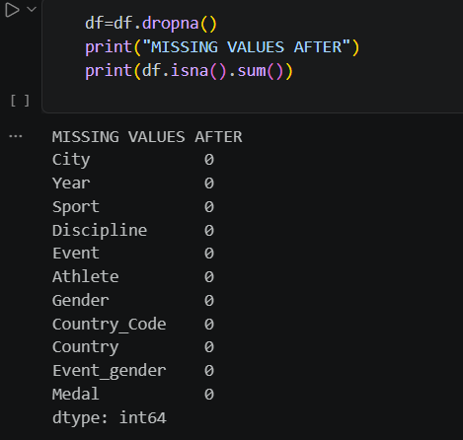
- Task 3 Detect and handle outliers using IQR.
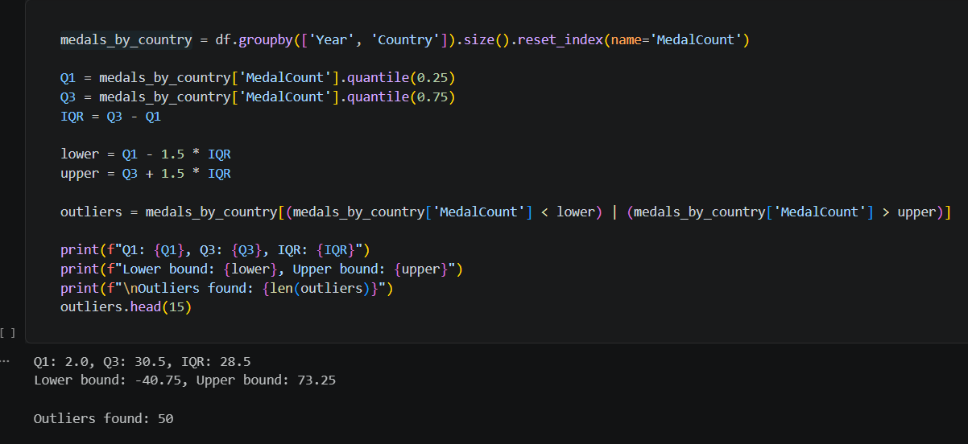

- Task 4 Normalize numerical features using both Min-Max and Z-score.
- Min-Max
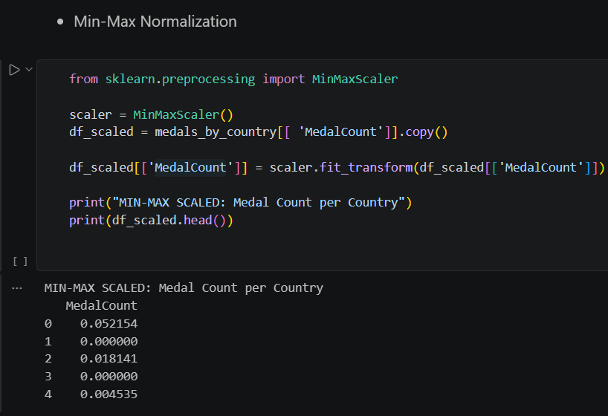
- Z-score.
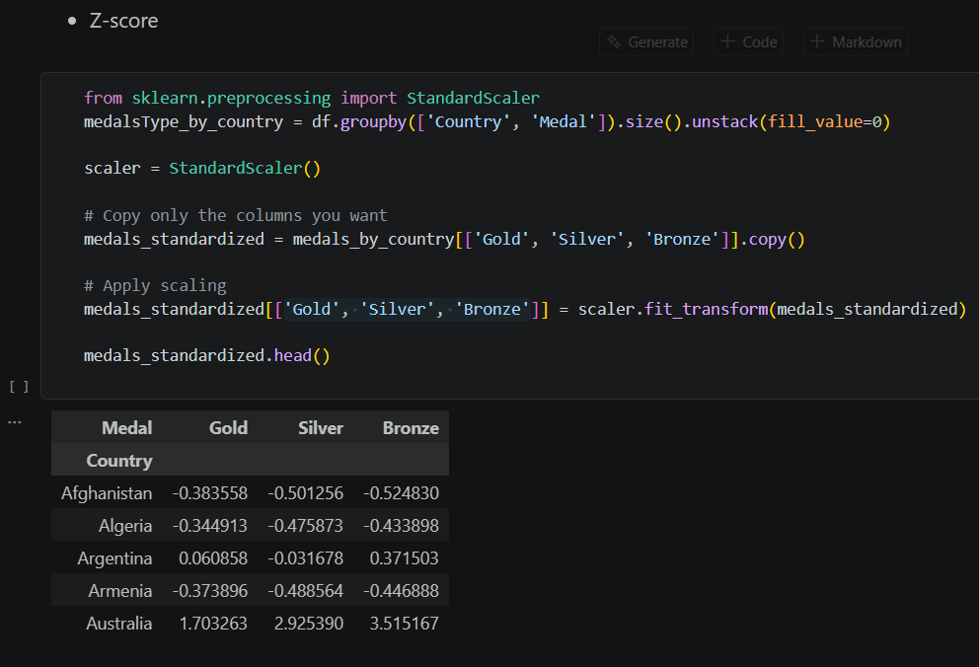

- Task 5 Apply PCA and interpret explained variance.
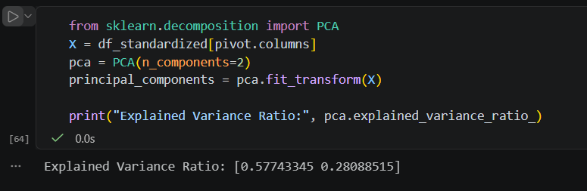
- PC1 explains 57.74% of the variance
- PC2 explains 28.09% of the variance
- Total: 85.83% (PC1 + PC2)
- PCA reduced the 9 Olympic years to 2 principal components explaining 85.83% of the total variance (PC1: 57.74%, PC2: 28.09%), indicating that Olympic performance can be effectively summarized by overall success and temporal trends.
